# Name: Abdurrahman Qureshi

# Roll no: 210451

## Practical no 14: -

## Aim: PL/SQL Programs Using Based on Exception Handling

* Exercise

1. Write a PL/SQL program by using predefined exception

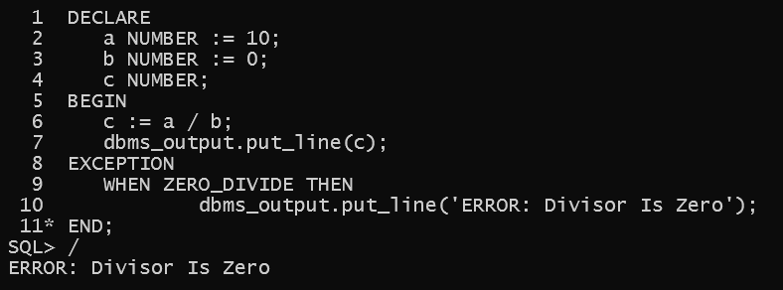

1. Write a PL/SQL program by using user-defined exception.

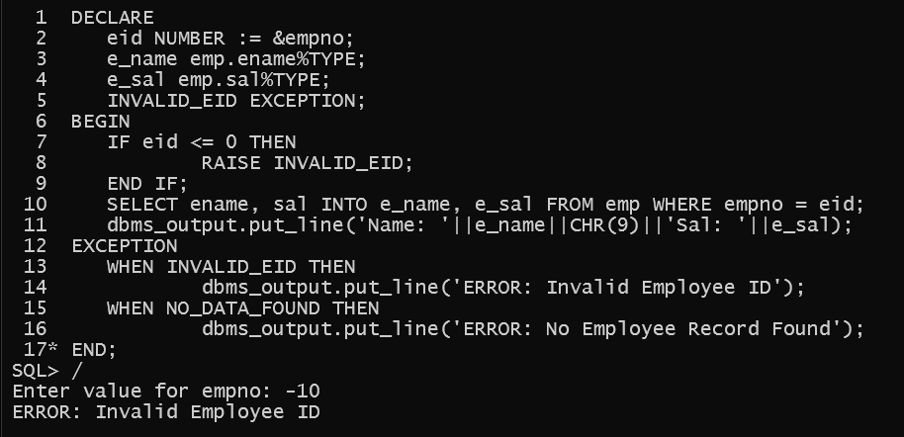

3.a)

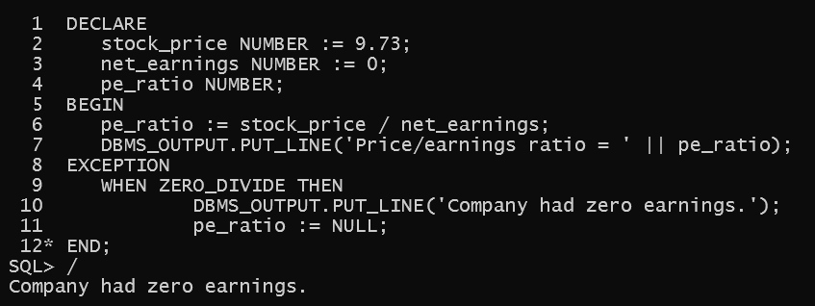

3.b)

